SEED IV

_________________________________

| **Model** | **Train Accuracy** | **Loss** | **Test Accuracy** |
| --- | --- | --- | --- |
| **CNN** | 0.6584 | 0.9327 | 0.6101 |
| **LSTM** | 0.8801 | 0.3449 | 0.8453 |
| **CNN+LSTM** | 0.8001 | 0.4585 | 0.7768 |

**CNN**

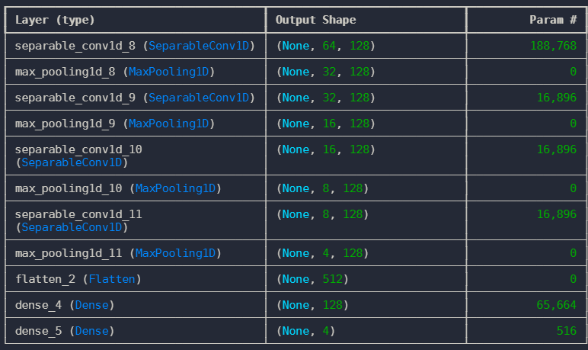

**LSTM**

